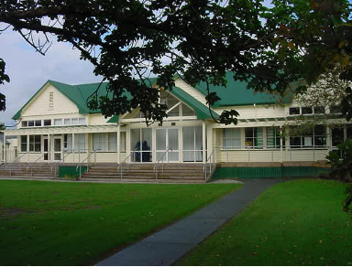 Hora Hora School

22 Te Mai Road, Whangarei
Phone 09 438 3080 Fax 09 438 9047
Email office@horahora.school.nz
Website http://www.horahora.school.nz

Principal Pat Newman T.T.C. Dip Ed(Waikato) B.Ed(Massey) Dip.Tchg, ANZPF

TIME LINE FOR the Senior Teacher Position

The following is the TIME LINE for the Appointment Process.

- Job advertised in the Gazette electronically Nov 21st 2022 approximately

- Job Application must be received at the School Office by 4.00pm 28th November 2022

- Application Process commences 4.00pm 28th November 2022.. This will take some time, as it generally involves shortlisting extensive background checking, committee input and interviews where necessary.

- We are not required to interview every or even a short list of applicants. We may do so depending upon the applications received. HOWEVER, we are required to carryout an “Identity Interview”, for the successful applicant

- Successful applicant should be able to be notified at latest by early De4cember prior to schools shutting.

- This notification will be dependent upon the Vulnerable Children Interview Requirements (All successful applicant must be interviewed by principal and identity established using Passport, Drivers license etc.) but could be earlier.

- Once successful applicants are notified, all other short listed applicants will be contacted.

